ADHD/ADD Informational Page

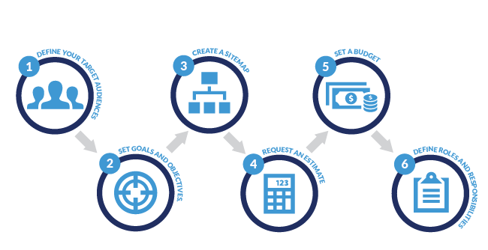

**Step 1. Define your target audiences.**

First, you need to decide who you’re designing the website for.

We asked ourselves:

* **Who uses our website?**
  + Parents, Children, Adults with undiagnosed ADD
  + People looking for answers and testimonials
* **What do they do while there?** (What pages do they visit? How long do they stay on each page? What path do they take to and from that page?)
  + The main goal for this site is for people to learn about ADHD/ADD with fun interactive graphs.
    - Interactive Graphs
    - Quiz
    - Information about ADD/ADHD
    - Treatment Options
      * Medication
        + Different types of medication and side effects for each
        + Market cost for each (Uninsured)
      * Non-Medication Treatment
        + Counseling

Costs

Testimonials

* + - * Tips and trick

Healthy habits

* + Really helpful links to outside information
  + Game similar to the Wikipedia game but on a browser that records clicks. ADHD FUN GAMES
  + Tools for being Productive
    - Pomodoro Timer
  + My Personal Testimonial as a college kid with no insurance
* **When do they visit?** (What day and time?)
  + All the time
* **Why are they visiting?** (What do they want to accomplish on our website?)
  + They want to stop hurting, they know what they need to do but cannot.
* **How do they visit?** (What device do they use—desktop, mobile, or tablet? What web browser did they use?)
  + **Mobile/Desktop Browser**
* **Who do we want to visit our website who isn’t already?** (How would they find us? What would they be looking for?)
  + **Google Search**
  + **Youtube**
  + **Facebook**
  + **News media**
  + **Local Paper**

**Step 2. Set goals and objectives.**

**GOAL:** I am making a website that teaches about ADHD and your options to overcome the set backs it might induce in order to enjoy thrive in life and not just survive. We are in a point in humanity that we no longer need to fight to survive, but people with undiagnosed ADHD fight everyday, and they don't even know it. Even the most simplest things in life to them are INCREDIBLY hard and they assume it will always be like that, road block after block and frustration after frustration, it wears them down to the point that they are no longer who they used to be or love to be and they eventually want to stop trying. **If I can make a website that educates and can convince one person who has doubts to see a professional, and have their life changed like mine, I would fulfill what I feel is my calling. I also want to advocate the love and power of Jesus Christ. It sounds gay but I want my website to help people like Jesus helped me**

Our objectives—how we planned to accomplish it

* **Interactive -** There needs to be a lot of simple bells and whistles that keep an audience with ADHD/ADD staying on the site.
* **Bold Colors** -that contrast, not necessarily bright but definitely eye catching. It has to be fun for children but also legit (take the site seriously) to parents and undiagnosed adults.
* **Educate**– I want to give as much information as possible in a manner that someone with ADHD can sit through and digest in a manageable/easy way that is entertaining/visually captivating. This information is to be used to empower the potential in the world.
* **Motivating** – This sites #1 objective is to give people hope and to motivate them to go out and seek help. Help that can/will change their life. No pill or appointment will cure this, but it will give them a tool to carry the ball and chain that has been making their life difficult.

**Step 3. Create a sitemap.**

Before we could estimate how many hours it would take to develop the website, we needed to know what the website might include.

So our web team created a new sitemap using the following steps:

1. We used the sitemap from our current website as a starting point.
2. We made sure all of our current services were covered.
3. We renamed some of the sections so their titles were clearer. For instance, “Downloads” became “Resources.” The top-level navigation didn’t change much, but the sub-navigation changed a lot.

USEFUL LINKS

<https://mitchgavan.com/react-quiz/>

<https://www.codementor.io/chrisharrington/react-vs-angularjs-how-the-two-compare-8t6f1ioan>

<https://betafamily.com/>

<https://vimeo.com/>

<http://www.firewatchgame.com/>

<https://gardenestudio.com.br/>

<https://html5up.net/>

<https://medium.com/@hamstu/recreating-the-firewatch-parallax-effect-213694d42f4e>